Marissa Dickey – ABWE Columbia

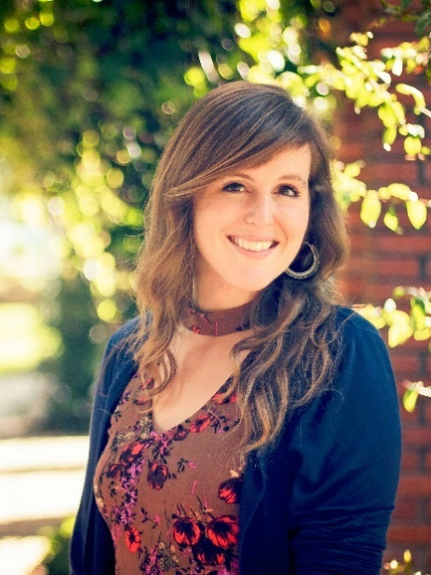
Marissa Dickey serves with ABWE ( Association of Baptist for World Evangelism) in the city of Medellín Colombia. Together with her team she works in church planting among the urban lower-class neighborhoods of Medellín known as the communes. They are currently working in a new church plant and seek to train others toward launching a Biblical counseling center.

Her ministry includes evangelism, discipleship training and ministering to families and at-risk youth. Along with these ministries she also serves her field team and organization as a multimedia specialist using photography and videography in missions for the furthering of the Gospel and the spreading of Kingdom vision and stories.

Contact: mkaydickey@gmail.com Whatsapp phone: (320) 956-4196

Charles and Nancy Ellis – Baptist Mid-Mission; Midwest Director of Enlistment
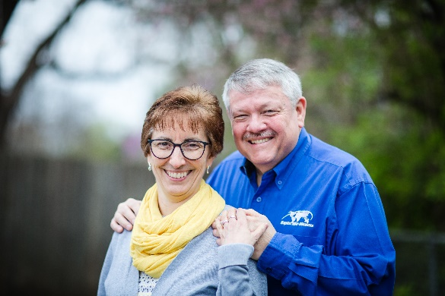
Charles is a graduate of Faith Baptist Bible College and Theological Seminary. He has a Doctor of Ministry degree from Northland International University Graduate School. He served as Senior Pastor of Grace Baptist Church in New Virginia, Iowa before being led of God to Germany. Charles and his wife, Nancy, joined BMM in 1984 and left for the field in 1987. After language study, the Ellises opened a new church planting ministry in Ingolstadt, Bavaria. Starting from scratch, God has built a church in Ingolstadt that is a great encouragement to all of the other church planting ministries with BMM in Germany and beyond. They are now a mother church, having birthed a new work about 30 miles to their north in Eichstaat. During furlough Charles also had the honor of serving on the Adjunct Faculty of FBBC teaching in the Missions Department. Knowing the great need for new missionaries, after 23 years with BMM in Germany, God has led Charles to accept Baptist Mid-Missions' offer to become the Midwest Director of Enlistment. These duties began in November 2007. Charles brings a trusted background in Pastoral, Missions, and Educational ministries. Charles and Nancy have 3 children and 10 grandchildren.
Contact: cellis@bmm.org Phone: (515) 779-9982

Dan and Christine Grings – IFM Democratic Republic of the Congo
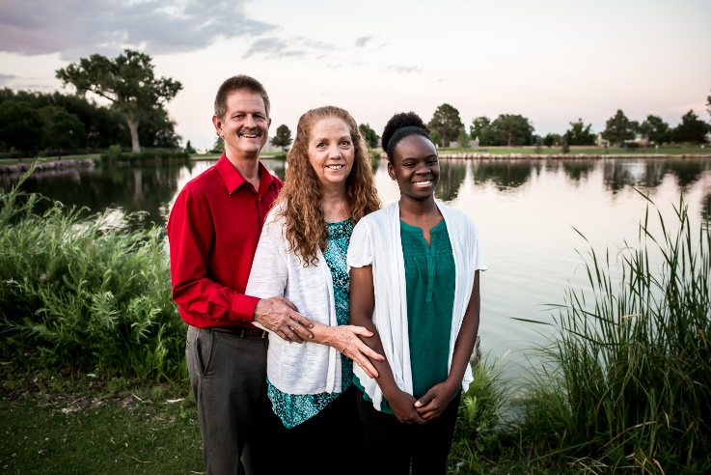
Growing up in the Democratic Republic of Congo (formerly Zaire) as a missionary kid was a privilege and blessing. I came to know Christ as my personal Savior at the age of 7 during a rebellion in Zaire. Christine grew up in Sandy, Utah, and came to know Christ at the age of 12 in a small Baptist Mid-Missions church while attending Awana. As a couple, Christine and I arrived in Zaire (Congo) in August 1983. We had the privilege of living and serving in the interior jungles from August 1983 to December 1995. There we taught in a Bible Institute, preached in the local church and traveled with the Bible school students planting churches within a 100 mile radius. During the civil war in 1997, our interior mission station was ransacked and looted. In 1998, we relocated to the capital city of Kinshasa and have had the privilege of serving as Pastor of the local church Nsango na Bomoi since 2002. Our ministry opportunities include Pastoral responsibilities and ministries, teaching in a Bible Institute, teaching chapels in both primary and secondary schools, and traveling extensively throughout Congo to evangelize and encourage local bodies of believers. We also work closely with our national leaders in our Association of Baptist Churches in Congo. We have seven children ranging in ages from 15 to 36, and have 19 grandchildren. We are presently in the USA on an extended furlough, and, Lord willing, plan to return to Congo in March 2021.

Contact: grings.daniel@ifmnews.com Phone: (716) 410-4583

Jon Jenks – President Baptist Church Planters

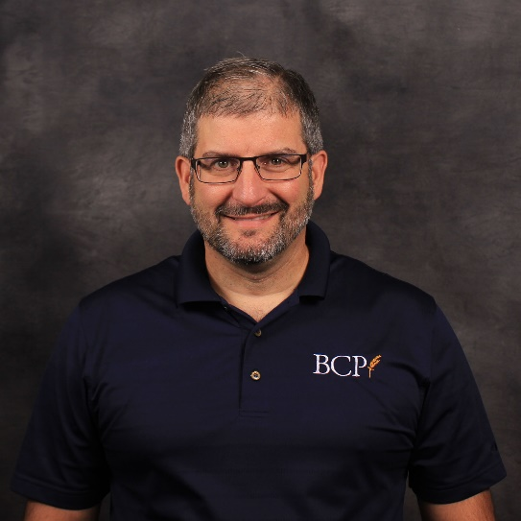
Jon’s passion as an administrator and leadership coach is to strengthen churches so that they reach the lost, grow believers, and multiply. His vision for Baptist Church Planters is that these strengthened churches might plant new churches and revitalize churches. Jon serves as the new president of Baptist Church Planters and continues to lead their efforts in revitalization and helping churches develop intentional discipleship. The Leadership Journey material for the men and The Grove for ladies has been used by God to mobilize a growing number of trainers and churches who work closely with Jon in this ministry. Jennifer, the love of his life, partners fully next to him in these endeavors.
This passion for God’s Church began in Jon through the ministry of his parents whom God is still using to revitalize and plant churches. Then God used, for over 20 years, the people of Calvary Baptist in Wisconsin Rapids, WI, who trained, loved, helped, followed, and served alongside of us with a focus on discipling intentionally at every age. We saw God grow the church, send over two dozen people into full-time ministry, plant a church, and allow us to serve many other churches. Calvary formed us and were formed by us. Calvary helped us rear and then launch our children, Rob, Joshua, and Abigail, into adulthood. Rob and his lovely wife, Alyssa, have recently launched Jon and Jen into grandparenting with Alayna, their granddaughter.
Jon loves to hunt waterfowl and upland game with his German shorthaired pointer, Blitz. These discipleship hunting opportunities are a highlight in his year. Jon and Jen have recently moved to Ohio with her parents who they care for. They are seeking to abide in Christ so that He might provide new opportunities to counsel, mentor, and witness in their new environment.

Contact: jjenks@bcpusa.org or gsebok@bcpusa.org Phone: (715) 572-5761

Clare and Donna Jewell – GARBC/ABWE Church planting/revitalization/emergency response

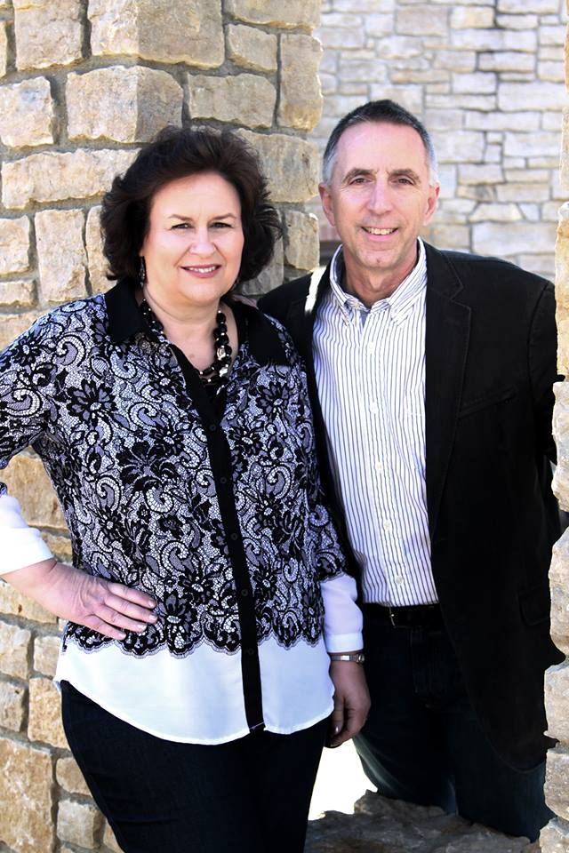
Clare Jewell served as the Senior Pastor of Lakewood Park Baptist Church for 21 years. In 2014, He joined ABWE and serves as the Regional Director for ABWE Every Ethne’ in the western region of North America and the National Director for Church Multiplication. In these roles, his primary responsibilities are:
1. To facilitate church planting in the US &amp; Canada
2. To help churches engage with ethnic groups in their region
3. To develop next generation leaders to participate in church planting and global missions
4. To oversee the ABWE missionaries serving in the Western region of North America &amp; help coordinate a strategy for the region

Clare also serves the GARBC as the national coordinator for church planting and the Director of Generate, a foundation of the GARBC that gives grants for church planting, church revitalization, church planter residencies, facility development and disaster relief. Clare is an adjunct faculty member at Corban University. Clare has a Bachelor of Science degree in Bible from Baptist Bible College in Clarks
Summit. He has a Master of Arts degree in Social Sciences from Eastern Michigan
University. He is currently working on a Doctor of Ministry in Strategic Leadership at
Corban University. Clare has been married to Donna for nearly 39 years. They have four daughters,
and 13 grandchildren.

Contact: cjewell@abwe.org Phone: (260) 466-9678

Jeff and Kristen Miller – The Master’s Academy International to Germany
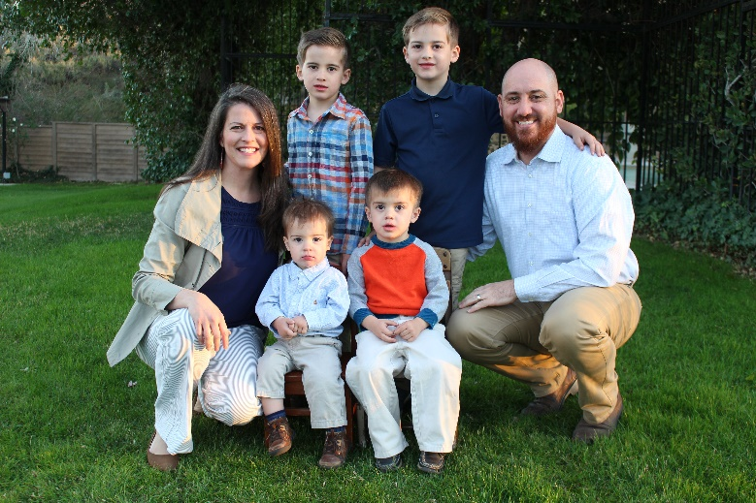
Jeff completed his undergrad degree in Construction Technology Engineering (a management degree for construction sites) and worked in this field for approximately five years before going to Chicago for seminary at Moody Bible Institute. Jeff met his wife, Kristen, while in school, but soon felt a desire for further training in expository preaching and expository counseling (biblical counseling). The Millers moved to California where Jeff completed his MABC (The Master's University) and M.Div. (The Master’s Seminary). Jeff is ACBC certified as a biblical counselor and enjoys being involved in the MABC program at the university in Germany, as the director of the program and as an adjunct professor. Kristen was a Labor & Delivery R.N. until the Millers' son, Dietrich, was born, and she now serves as a homemaker. Kristen loves to teach the boys and has a strong desire to disciple and counsel gals in the Word of God.

Ministry Description: To proclaim the Word of God—publicly and privately (from house to house, Acts 20:20)—with the hope of strengthening the church through preaching, counseling, and training ministries. The Millers have been asked to be part of a church plant in Berlin that just launched. It is their desire to be used by God in the preaching and teaching of God’s Word in the church. It is also a passion of Jeff’s to teach & train others in the classroom. He is excited for the opportunity to teach theology and biblical counseling classes in the TMAI training center (EBTC) to train others in Germany and throughout Europe. Additionally, Jeff plans to work closely with ACBC (Association of Certified Biblical Counselors) to help train and certify Biblical Counselors in Europe.

Contact: jeffkristen21@gmail.com Phone: (330) 606-1721

Paul and Carolyn Pierce – Friends of Israel NW Field Representative
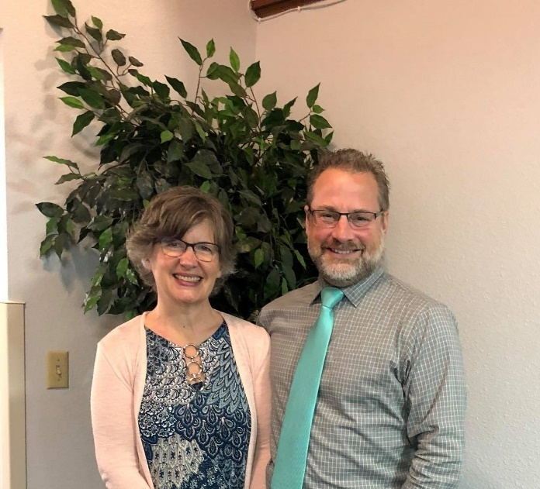
Paul Pierce was born and raised in Olympia, WA and came to Christ under the preaching of Ralph Poulson – a missionary to Brazil. He earned a B.S. in Pastoral Theology from Faith Baptist Bible College (Ankeny, IA). Upon graduation, Paul returned to his home church and served as the youth pastor for 16 years before moving on to Immanuel Baptist Church in Traverse City, MI as an Associate Pastor of Youth and CE. The Lord stirred his heart towards a shepherding ministry and led him and his wife, Carolyn, back to the northwest as a senior pastor for Sleater Kinney Road Baptist Church. While studying eschatology in Scripture, Paul’s interest in Israel, the Jewish people, the Old Testament prophets, and prophecy came alive. Burdened for the Jewish people, Paul and his wife became church ministry representatives in the northwest for Friends of Israel in 2017. As a Church Ministries representative, Paul is ministering to churches by teaching the biblical truths about Israel historically, currently, and prophetically, while at the same time seeking to establish contacts and relationships with Jewish people. His desire is to share God’s love and purpose for the Jewish people while addressing current issues facing the church today.

Contact: ppierce@foi.org Phone: (360) 280-2125

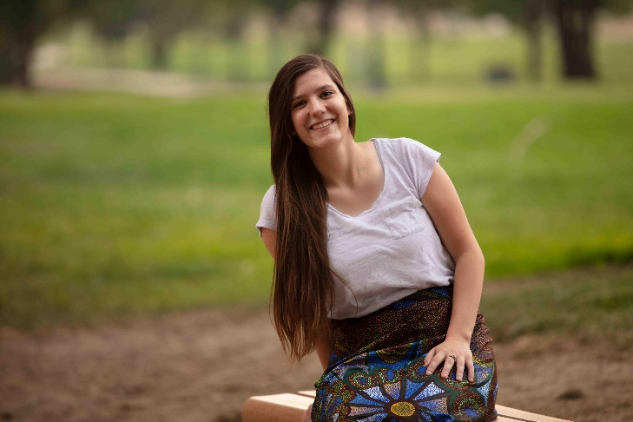
Faith Shaffer – ABWE Togo
I grew up in a Christian home and was saved at the age of six. I had always wanted to be a missionary. However, I had not really taken serious consideration of what I would do with my life until high school. In my sophomore year of high school through teaching Bible verses to kids in AWANA, I felt God’s calling on me to go to missions. However, I pushed the thought away out of fear. I loved working with kids and did not want to leave the comfort I was in. I could teach kids here in the States and be a light for Jesus to them. However that February, Megan Mackenzie came to our church for missions conference. She told us about how she was going to be a teacher to missionary kids in Africa! For me, this was the push over the edge in a sense. That day God opened my eyes to see that He wanted me in missions and He had a plan. He gave me a love for kids and a desire to teach for a reason. From then on, I have strove towards the goal of being able to teach the missionary kids in Togo. I will help bring the gospel to the unreached in Togo along with discipling and helping missionary kids grow closer to God. The goal is for them to become disciples of Jesus who will then go and make disciples for Him.

Contact: faith.shaffer@abwe.cc Phone: (208) 971-6213

